Medical Expense Prediction
Team:
- Akshitha Ralla
- Sakshi Oberoi
- Bansil Patel
- Harsh Mohite
- Rachit Bhatt
Purpose:
- A healthy body and mind become healthy life.
- Cost of treatment is what we will try to explore and decide for various patients.
- Many reasons are there for medical expenses such as age, city of residence, type of clinic, and diagnosis.
Libraries:
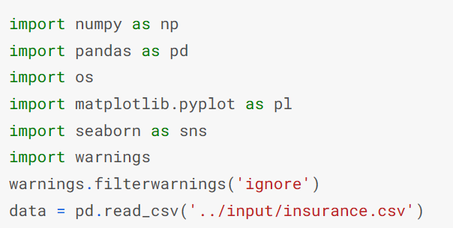
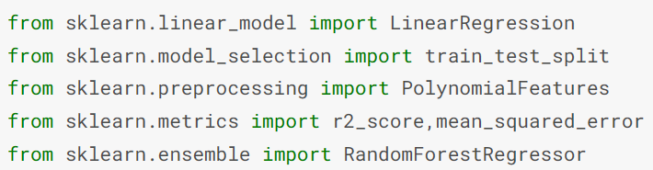
First look on the dataset:
- Luckly, no missing content was found which increases the veracity of this dataset.
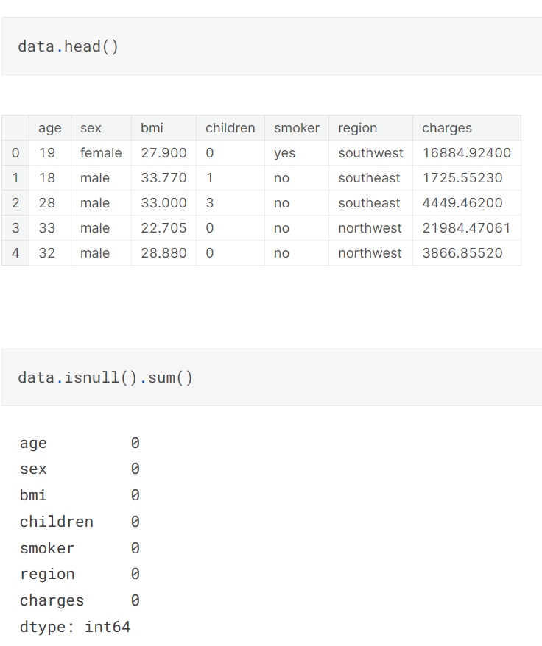
Label Encoding:
- Since we need to predict the amount of costs, we will encode the categorical features.
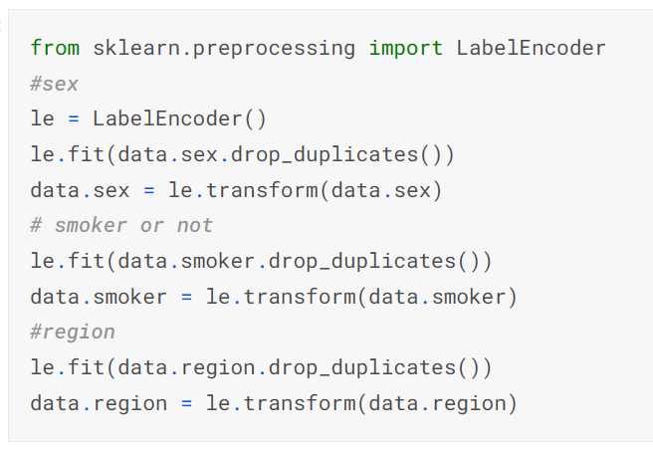
- In general, categorical variables with large variability are best encoded using OneHotEncoder.
- However, in this case, since there is no special order in which the regions would be listed, nothing will change.
Correlation:
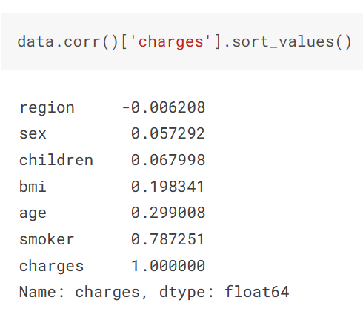
- A strong correlation is observed only with the fact of smoking the patient; hence, we will deep-dive into smoking in detail.
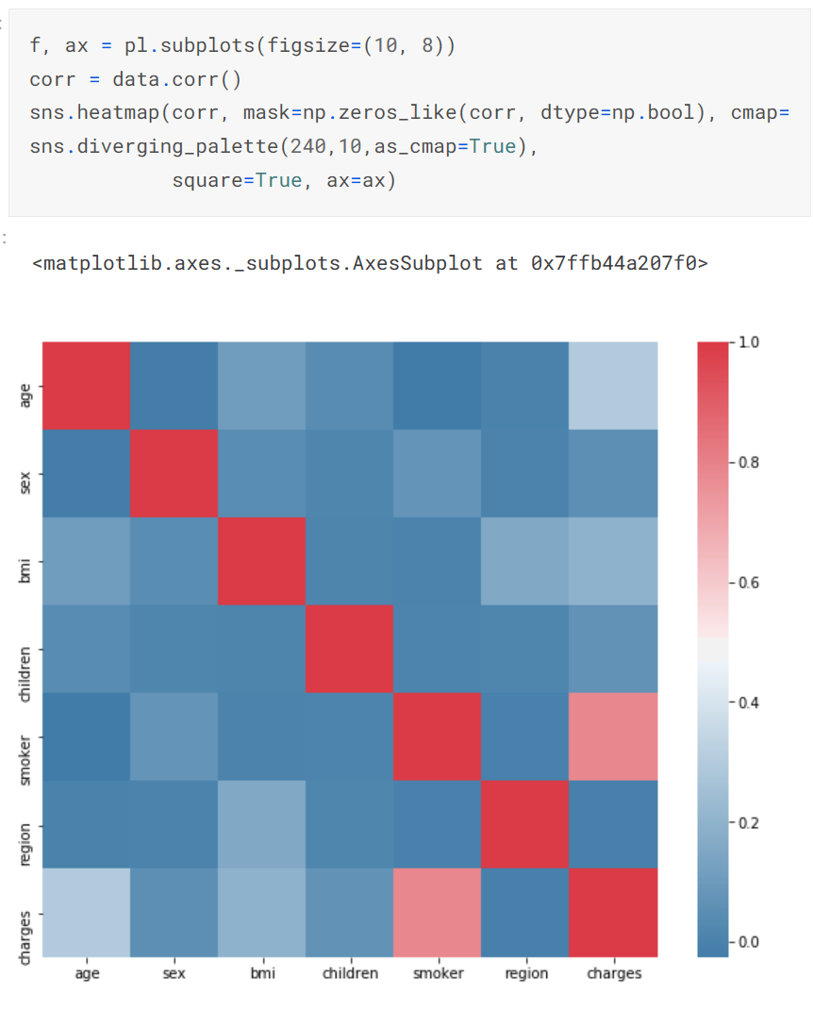
Distribution of Charges:
- This will help to know how much patients spend on treatment on average.
- Although it is not necessary, it will give an overview of the patient’s financial condition or medical charges.
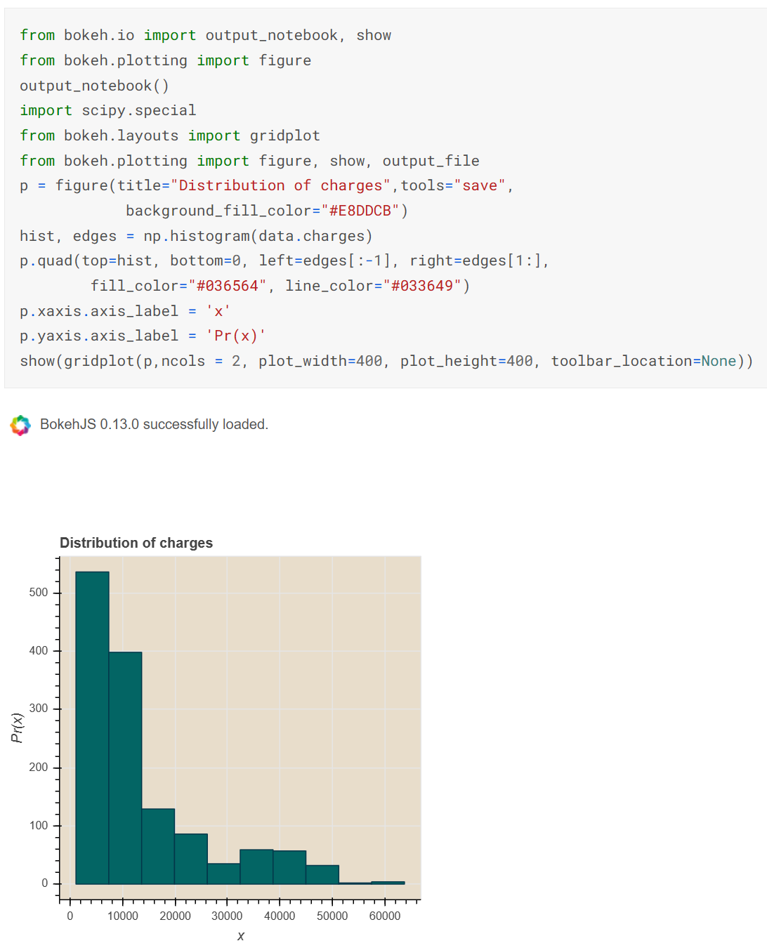
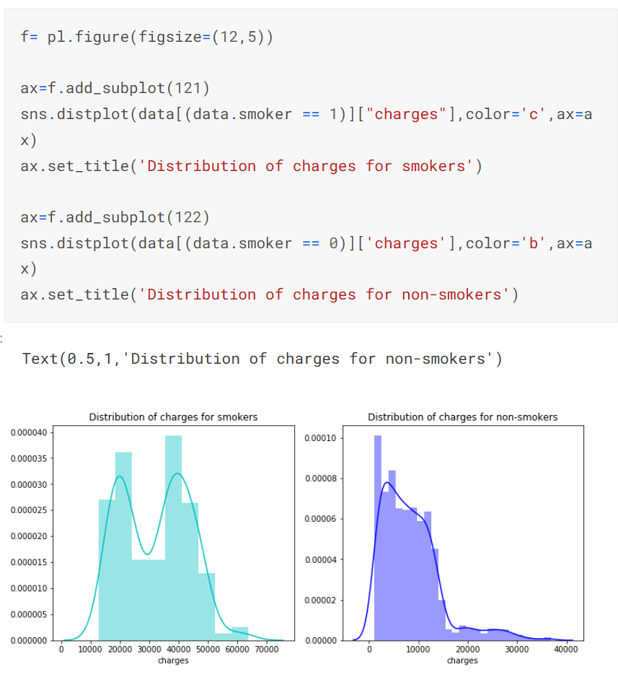
- As we can see, smoking patients spend more on treatment, but not as greater as of non-smoking patients.
Smoking Patients:
Gender-Based Distribution:
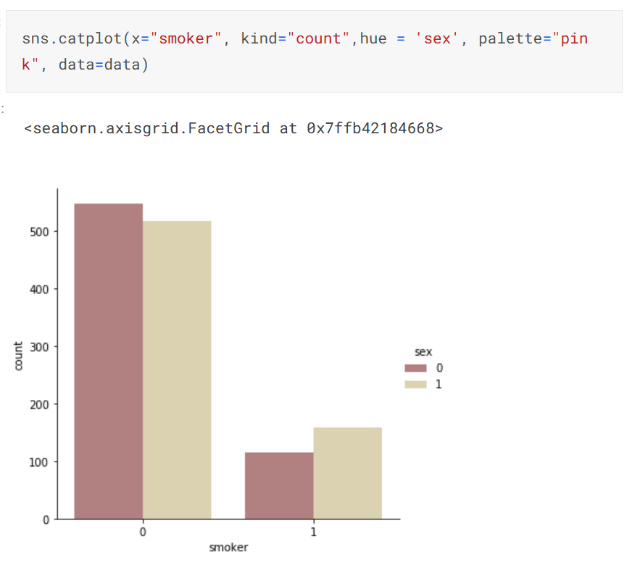
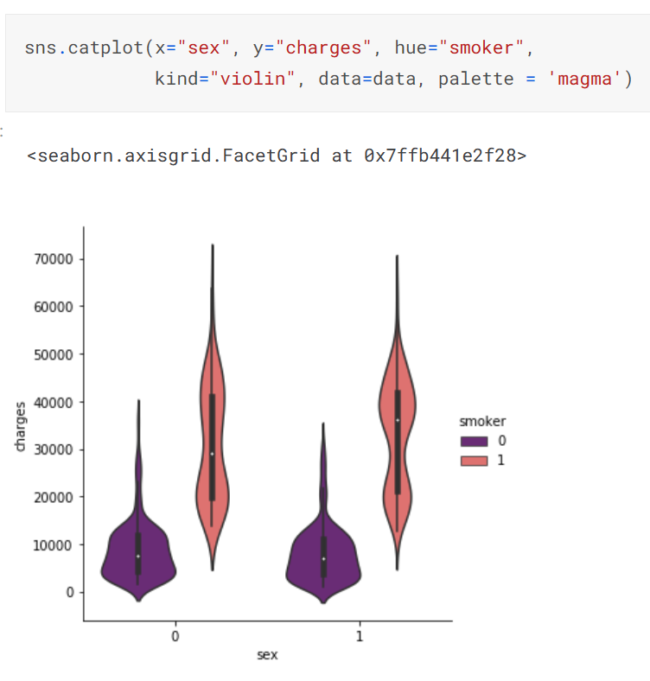
- If we consider males as “0” and females as “1”, with the help of cat-plots, we can conclude that more men smokers exists than women.
- We may assume that the total cost of treatment in men will be more than in women, given impact of smoking.
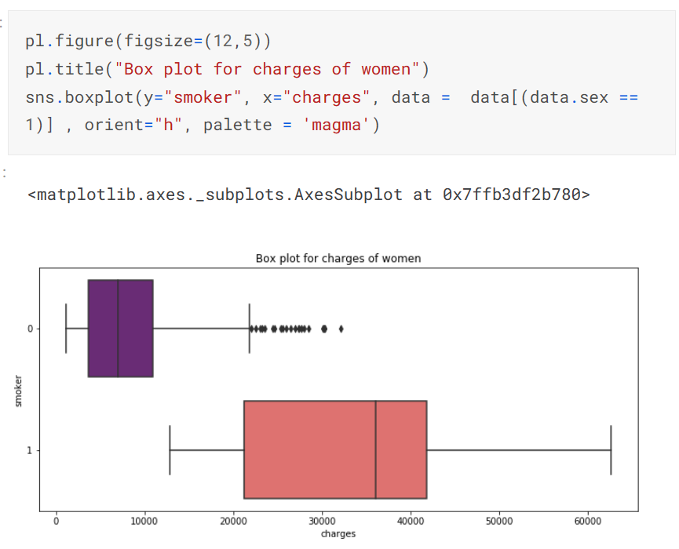
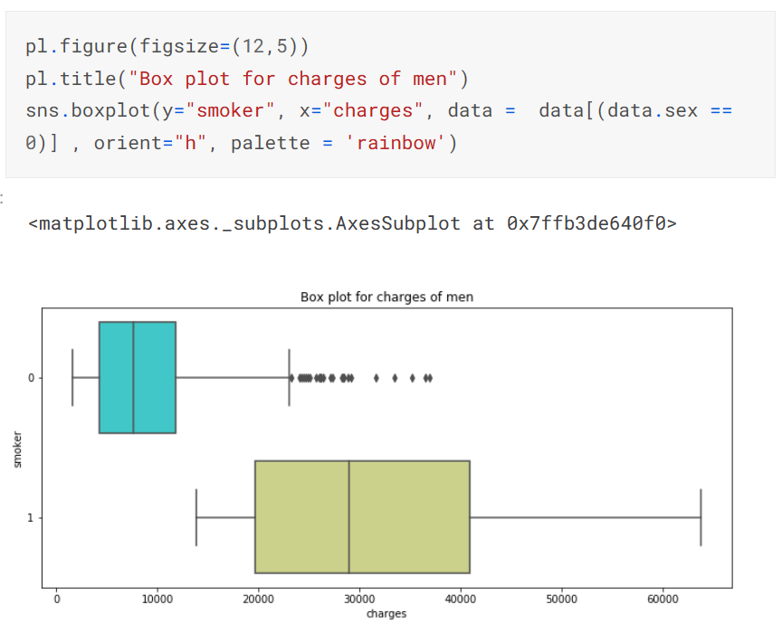
Distribution of Age:
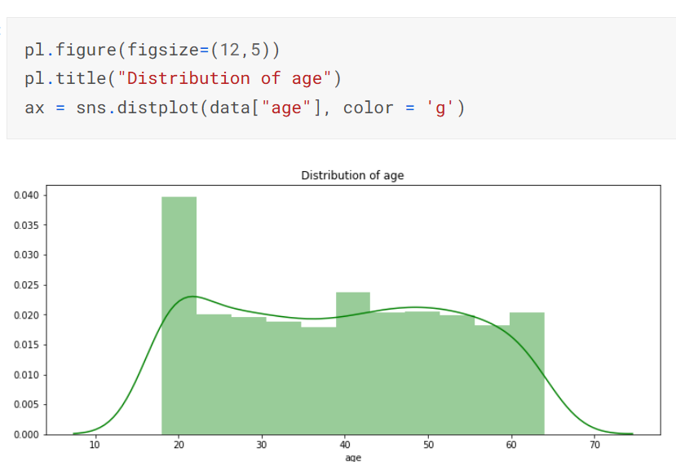
- We are having a few patients under 20 as well while the minimum age of patients should be 18.
- The maximum age is 64.
Determining Smokers at the age of 18:
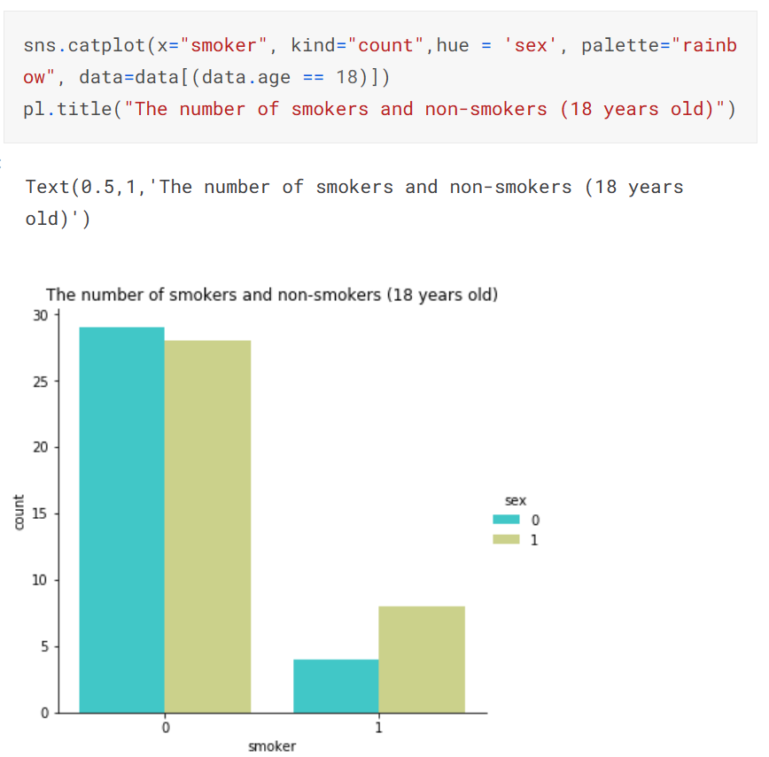
Does smoking affect the cost of treatment at the age of 18?
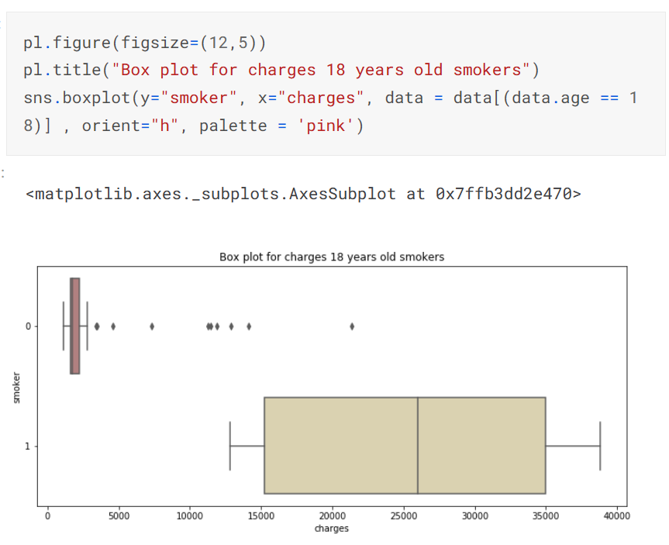
- Even at this young age, smokers spend much more on treatment than non-smokers.
- We may assume that the non-smokers are having some tails is because of serious diseases or accidents.
How treatment cost depends on age of smokers and non-smokers patients?
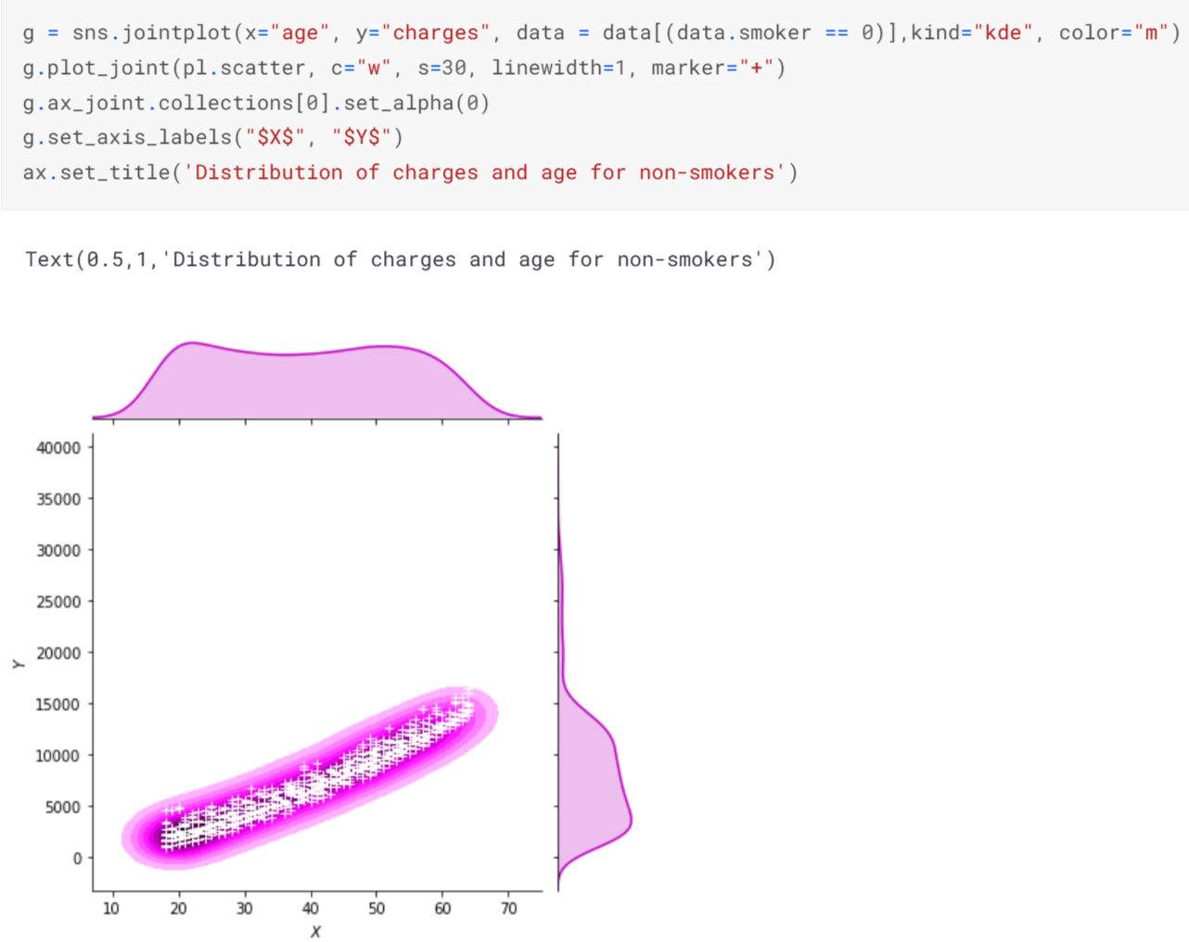
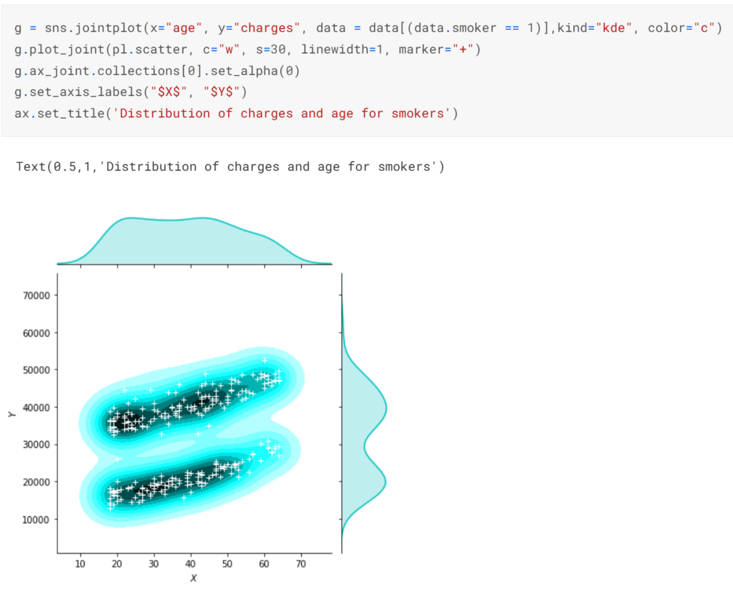
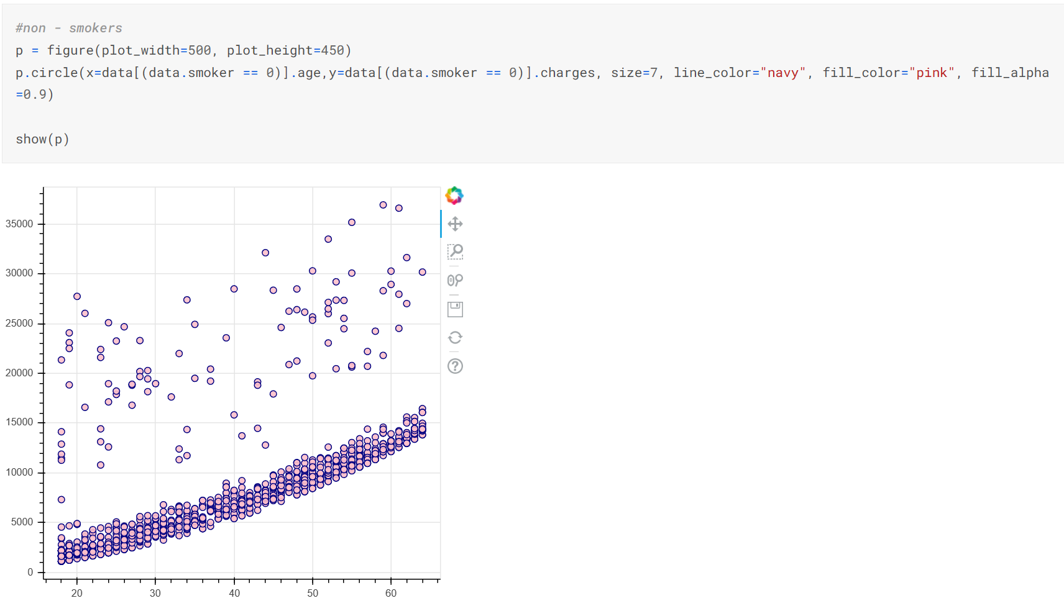
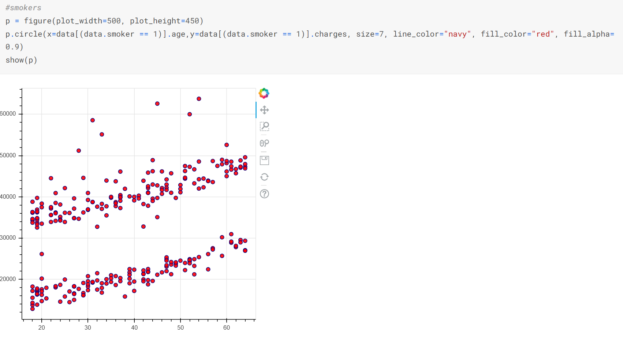
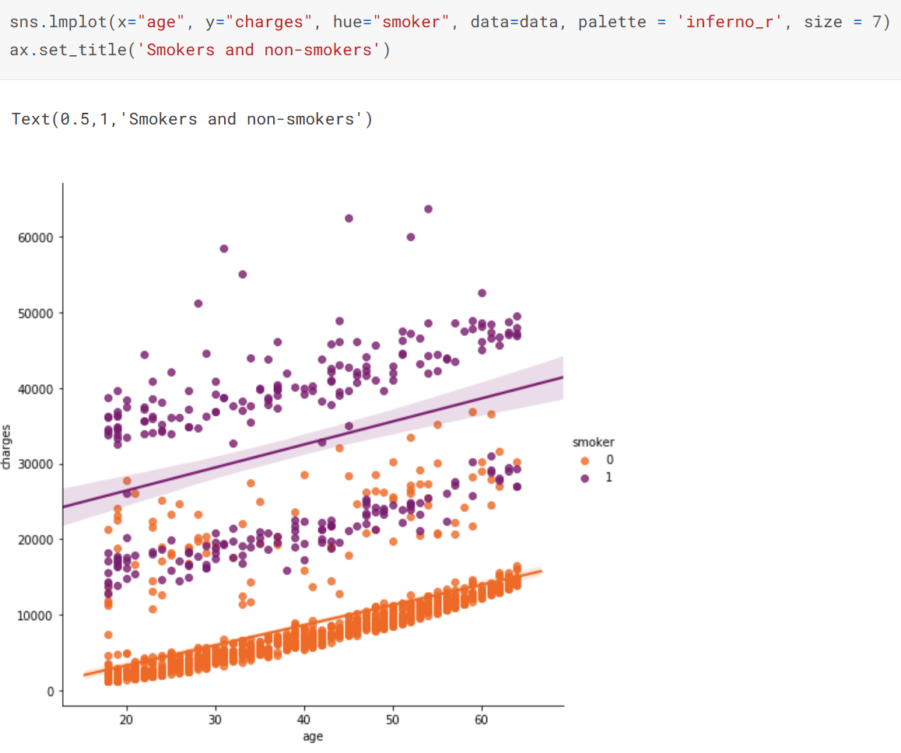
- The cost of treatment increases with age for the non-smokers, which makes sense.
- Smokers do not have such dependence.
- Such a strong effect of smoking on the cost of treatment would be more logical to judge having a set of data with many records and signs.
Distribution of Diet/BMI?
- Let us pay attention to BMI (Body Mass Index) and let us see how the diet affects the cost of treatment in patients.
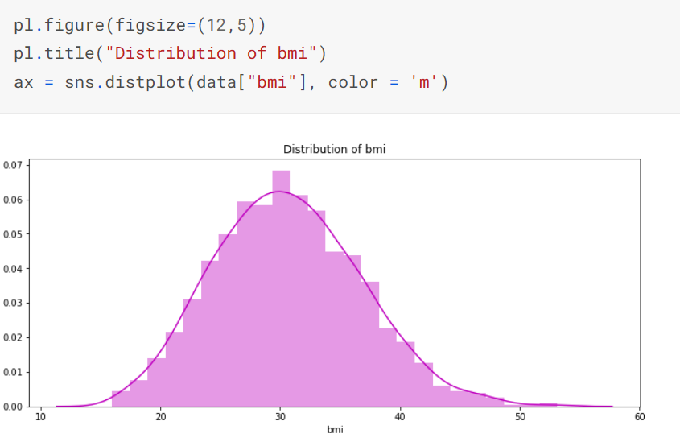
- Average BMI in patients is 30.
- With a value equal to 30 starts obesity.
Distribution of charges for patients with BMI:
Greater than 30:
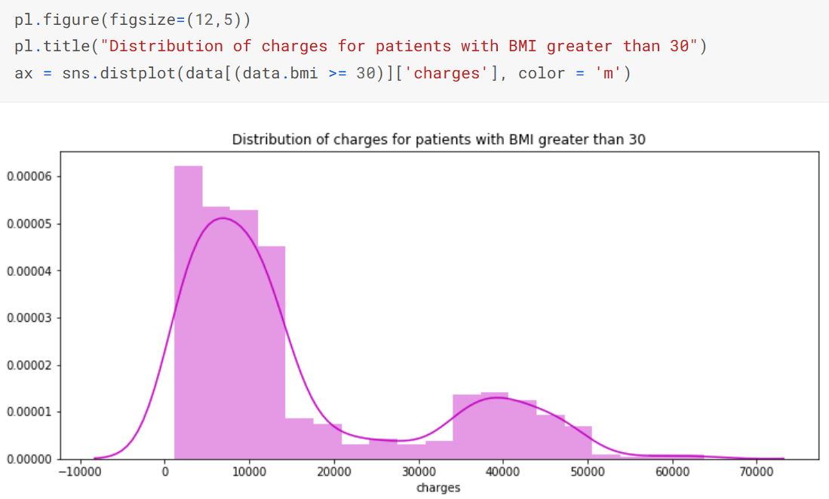
Less than 30:
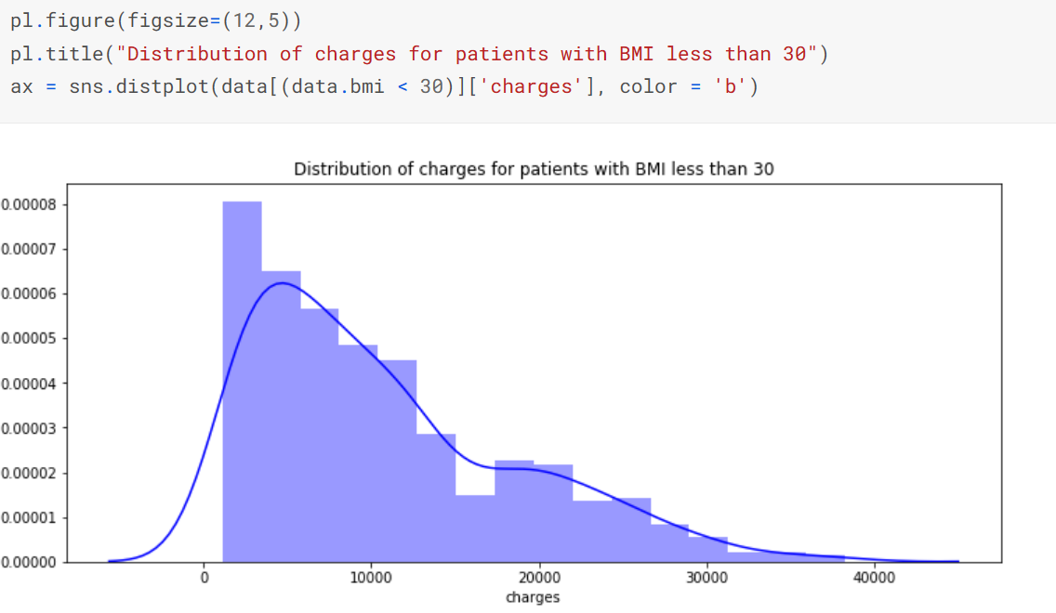
- Hence, patients with BMI above 30 spend more on treatment.
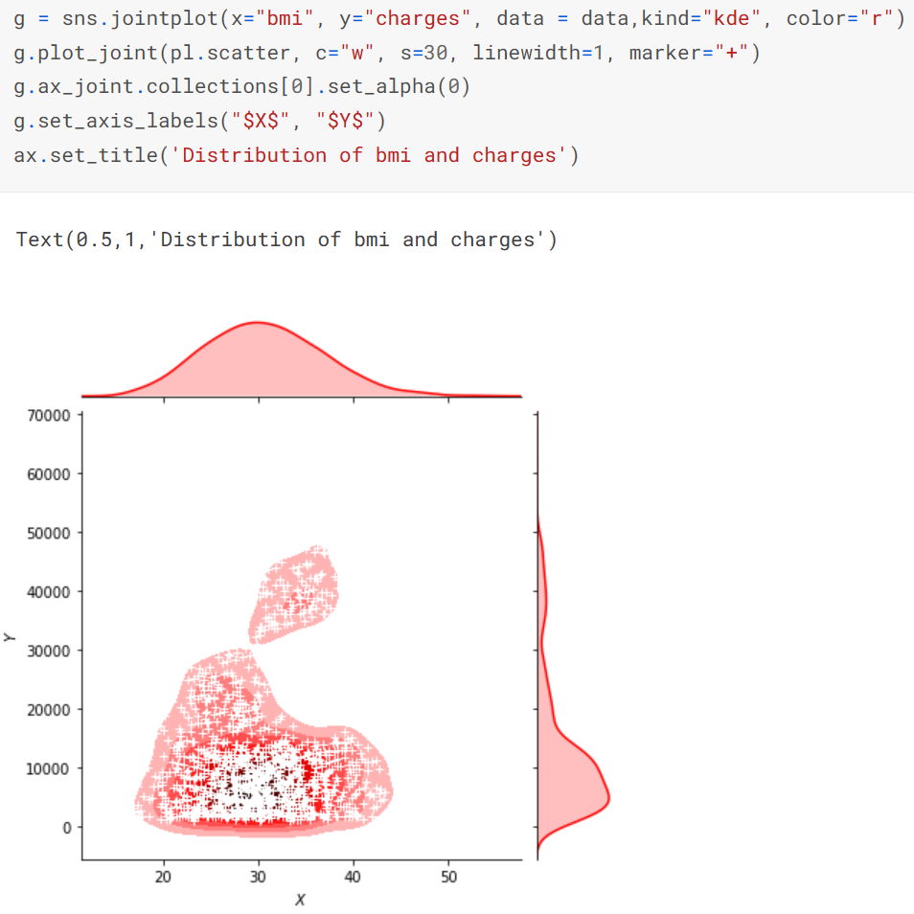
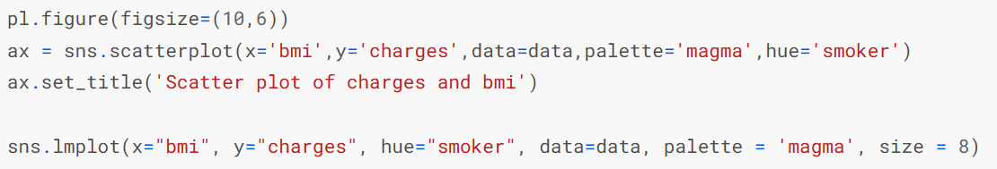
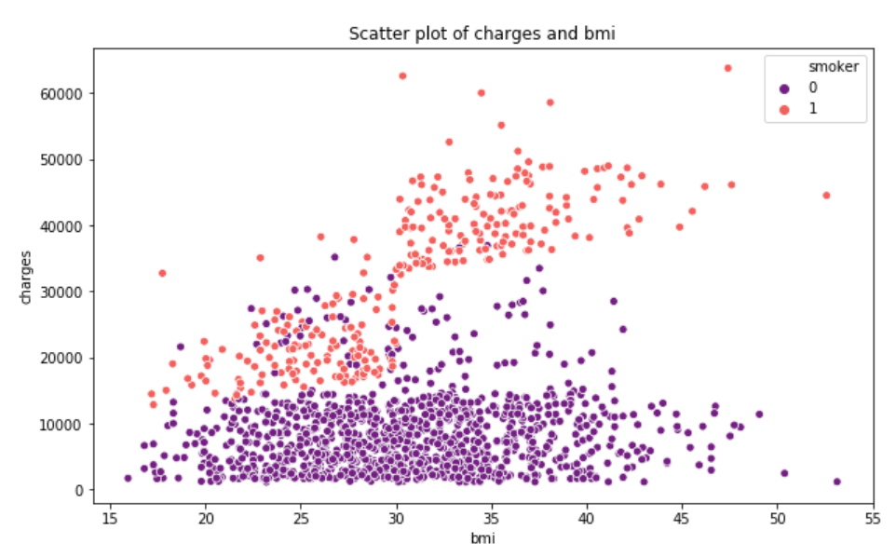
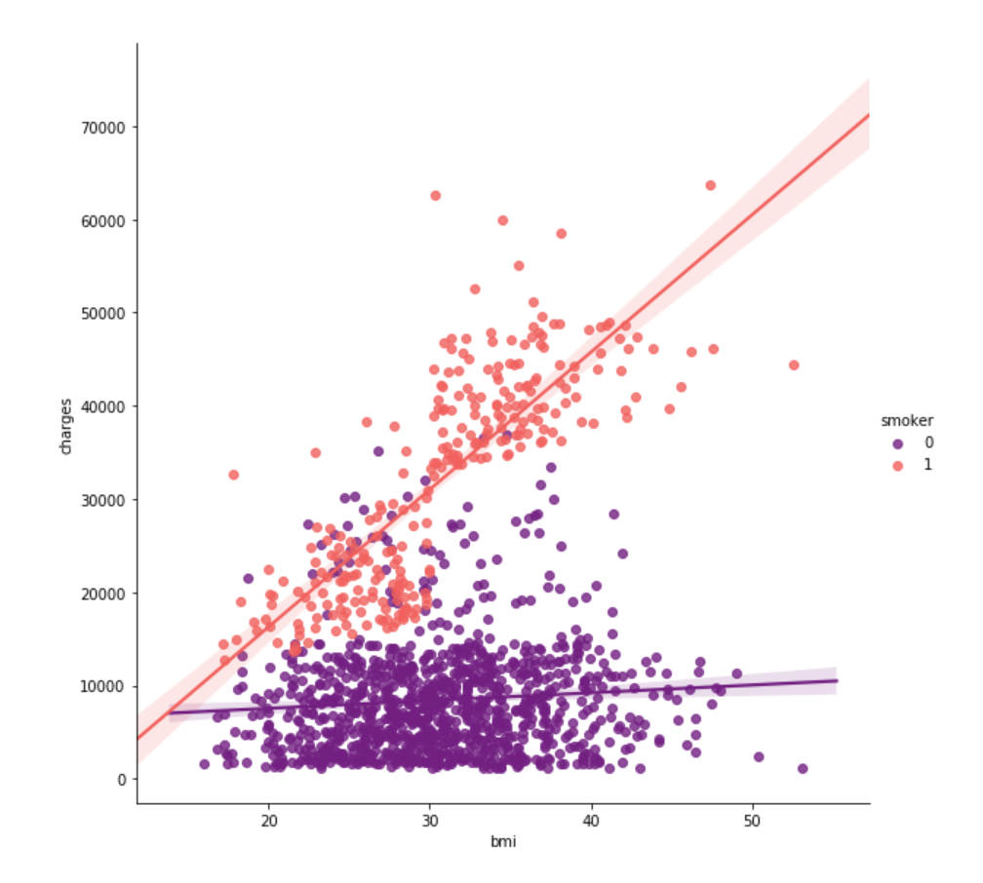
Invigilate Children:
- Figuring out how many children our data set contains.
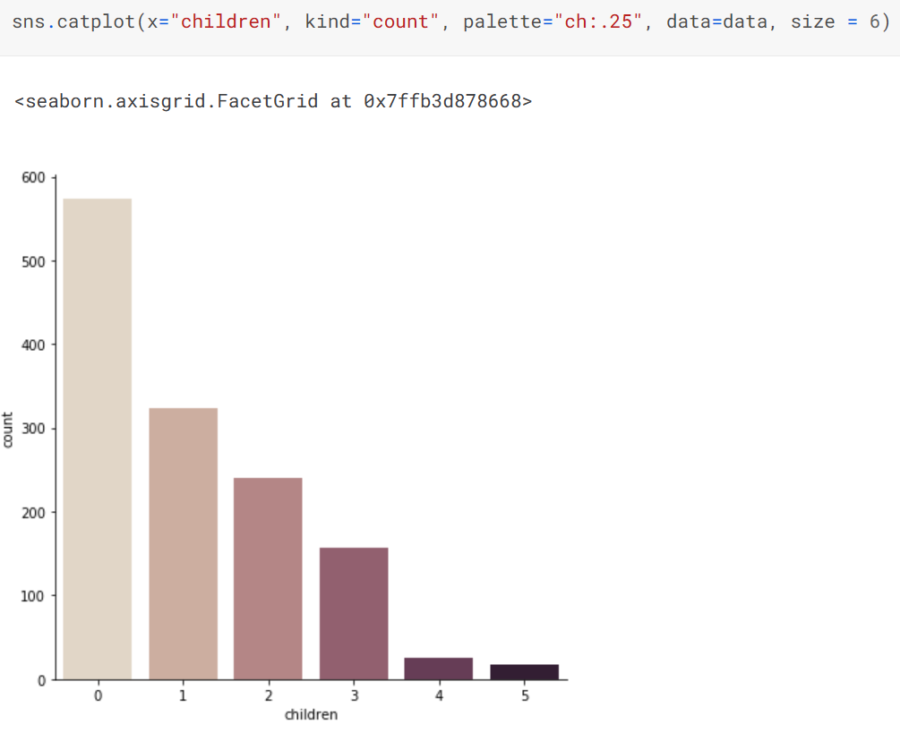
- Most patients do not have children.
- Wondering if people who have children smoke.
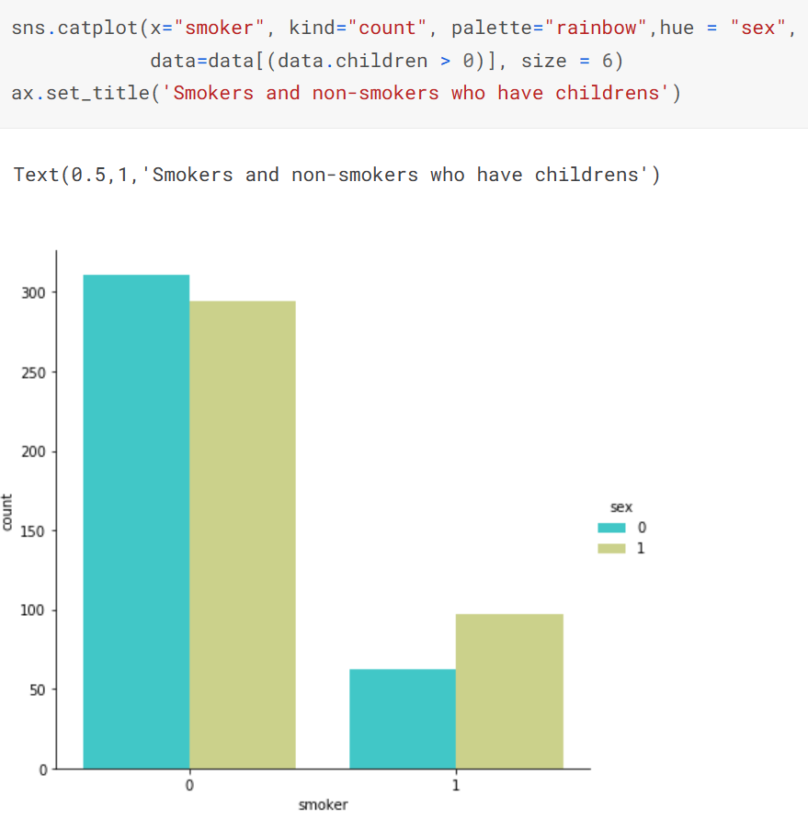
- Yet, the non-smoking parents are much more.
Prediction using Regression:
Libraries (as mentioned in the beginning):

Linear Regression:
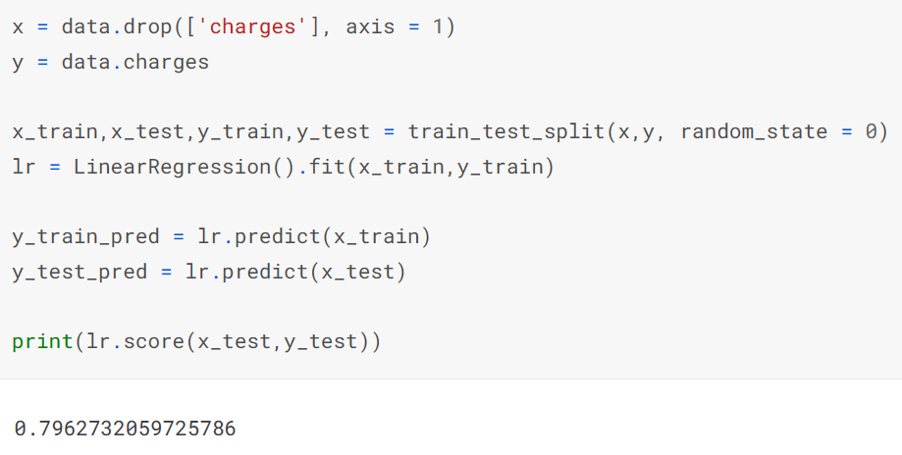
- 79.62% accuracy seems good, especially when doing without data normalization.
Adding Polynomial Features:
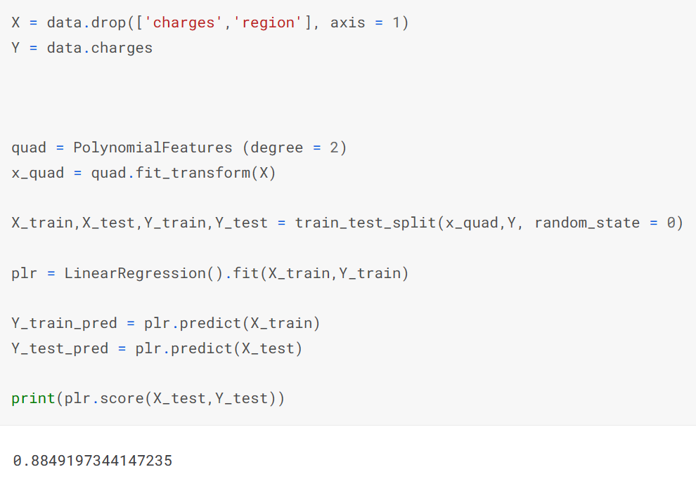
- 88.49% accuracy is where our model predicts the cost of treatment of patients on the test-dataset given training dataset.
- We could limit ourselves to creating two or three polynomial features for better results, but this dataset might not suit that case.
Random-Forest Regression:
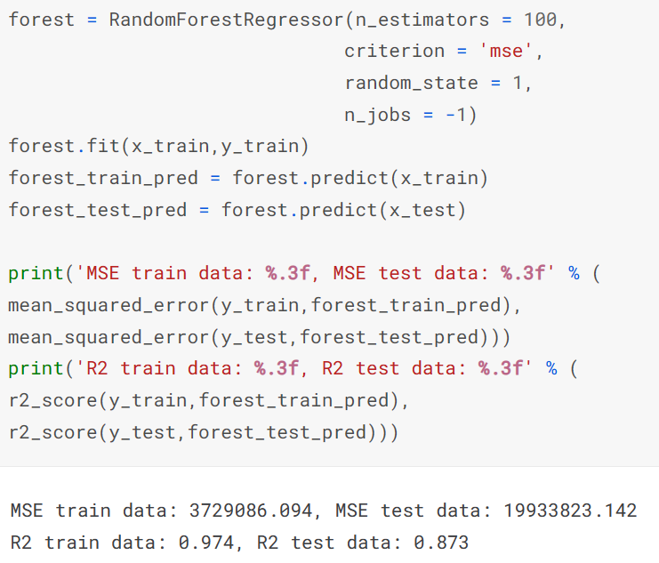
Visualizing the test and train data:
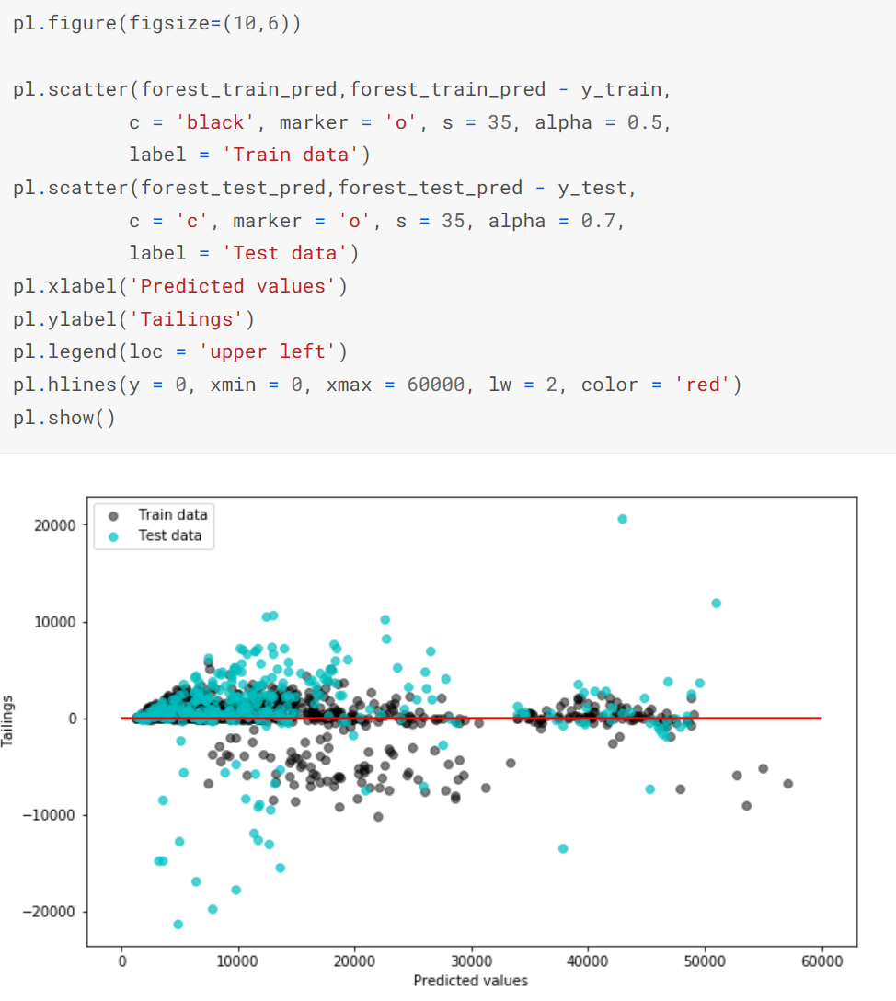
Conclusion:
- Smoking patients, especially men, are paying more than non-smoking and women patients.
- There are a few patients who smoke at the age of 18 and do pay a lot of money for their treatments.
- As the age increases, the non-smoking patients’ treatment cost increases.
- Most patients’ BMI comes close to 30, yet above 30 spends more on treatment.
- Hence, a good health depends on a healthy body and mind.

